Experiment 1: Probability Theory (20 Marks)
Dataset: Breast Cancer Wisconsin Diagnostic Dataset
Task:
Using the Breast Cancer Wisconsin Diagnostic Dataset, calculate the probability of each class(Malignant and Benign) and use the computed probabilities to predict the class of a new data instance.

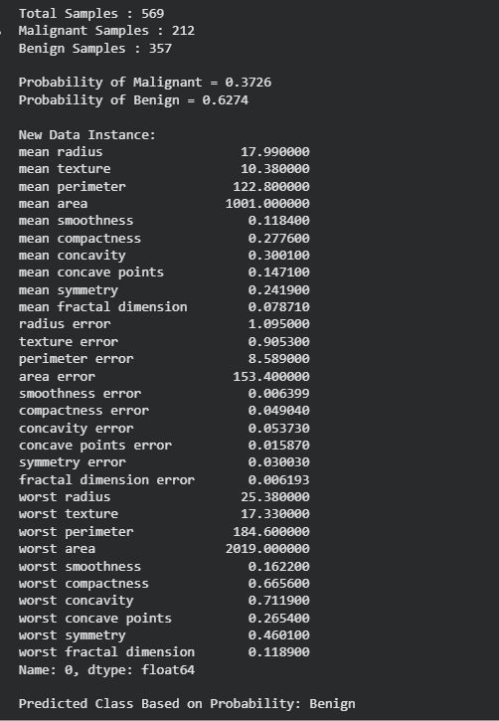

Experiment 2: Bayes Decision Theory (15 Marks)
Dataset: SMS Spam Collection Dataset
Task:
Using the SMS Spam Collection Dataset, implement Bayes theorem to calculate the posterior probability for a given message and classify it as Spam or Ham (Not Spam).
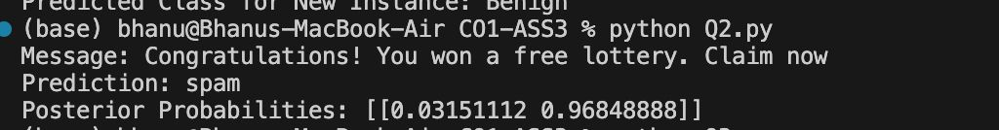
Experiment 3: Information Theory (15 Marks)
Dataset: Play Tennis Dataset
Task:
Using the Play Tennis Dataset, calculate the entropy and information gain for all

